***3in1 v3.6 Release Notes***





**With the release of 3in1 v3.6 on 4/27/2016, the 3in1 Team is pleased to announce the following updates to the 3in1 Tool system:**

* **Enabled Capability to Provision 3in1 Device through GSM/WiFi**
  + Previously, a 3in1 Device could only be provisioned via Ethernet (hardwired internet) connection. As of this release, a 3in1 Device may now be provisioned through a wireless internet connection. This new feature will allow system users more flexibility in provisioning, since Ethernet connections are not always available down-range in contingency operations/environments
  + Ability to provision a 3in1 Device is automatically enabled; however, this feature can be disabled within the 3in1 Website, if necessary
* **Expanded 3in1 Website capability to match pre-existing 3in1 Workstation functionality**
  + The 3in1 Tool system has vastly enhanced its website capabilities to match the capability of the 3in1 Workstation, including additions/enhancements of the following Website menus/features:
    - **Enhanced Login Page:**
      * Register New User
      * Change Password
      * Forgot Password
      * Login
        + Username/password combo login
        + CAC-enabled login

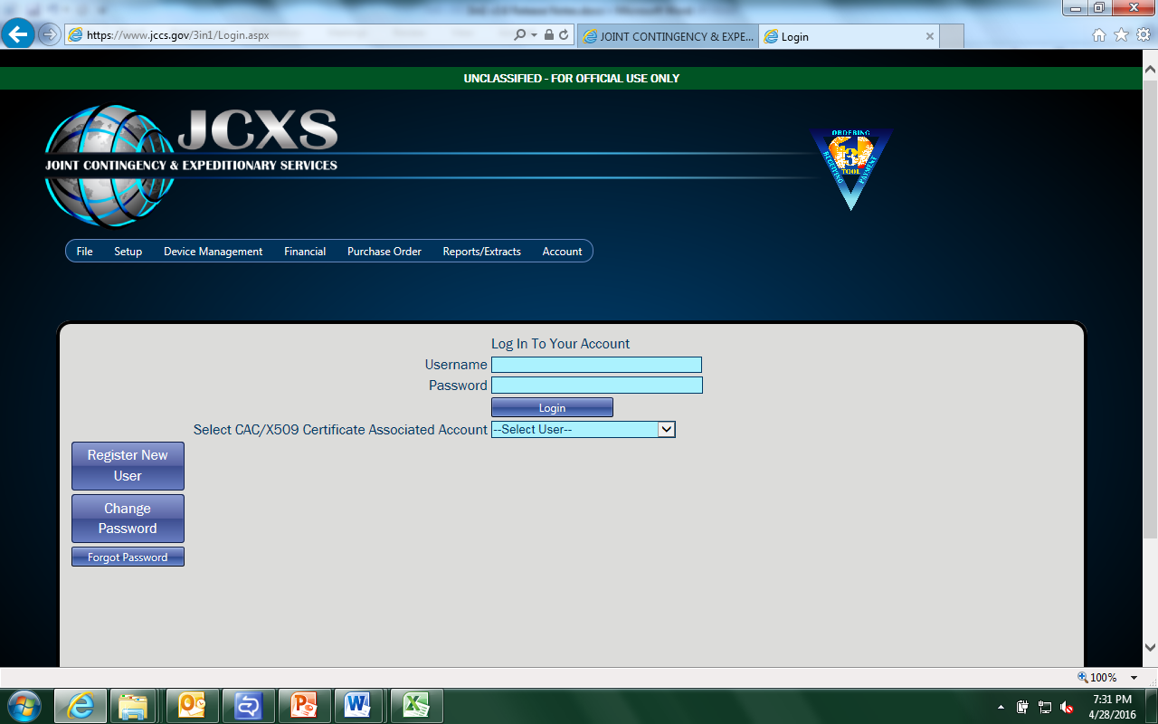

* + - **File:**
      * EDA Upload
      * Documents
    - **Setup:**
      * AOR Admin
      * Procurement Controls
      * RCC Default Clearance Configuration
      * Manage User Roles
    - **Device Management:**
      * Manage Device
      * Provision Device
      * Issue Mass PIIN Blocks
    - **Financial:**
      * Financial Admin
      * Add Purchase Request
      * DDS Interface
    - **Purchase Order:**
      * Clear Purchase Orders
      * Lookup Purchase Orders
      * Add Purchase Orders
      * Market Research
    - **Reports/Extracts:**
      * Accounting Log
      * Purchase Log
      * Property Purchase Log
      * Mass Download SF44
      * SF44 Report
      * Clearance Information
      * Active FOO
      * RCC Activity
      * Deprovisioned/Terminated FOOs
      * FOO Provisioning
      * Procurement Controls
      * Finance Office Funds
    - **Account**
      * User Profile
  + Users may now use the 3in1 Website in place of the 3in1 Workstation to conduct full end-to-end 3in1 system operations. This eliminates the previous requirement to install 3in1 software on users’ computers, and also eliminates the necessity of an Authority to Operate (ATO) in order to utilize the 3in1 Tool system.
  + The 3in1 Website has also been fully integrated with the JCXS COE Website, both functionally and visually. This allows a user to navigate to the 3in1 Website via the JCXS COE Website and access 3in1 Tool system functionality; in addition, the 3in1 Website utilizes a similar style template, promoting the same “look and feel” of the JCXS COE upon navigating to the 3in1 Website
* **Replaced hard-coded data lists with references to tables** 
  + The following data sets were switched from hard-coded to data tables:
    - Service Agencies
    - Units of Measure
    - Currencies
    - Countries
    - Device Endpoints
  + This reworks the 3in1 Tool system to access various lists of data referentially, instead of hard-coding them into various portions of the system, which complies with PRDS Data Standard
  + Prevents necessity of updating numerous pieces of the system just to add a particular type of currency/unit of measure/service agency/country/device endpoint
* **Expanded GIS Tracking Location functionality**
  + Two additional attributes within the Office structure data schema are now requested optionally
    - Latitude (of Office location)
    - Longitude (of Office location)

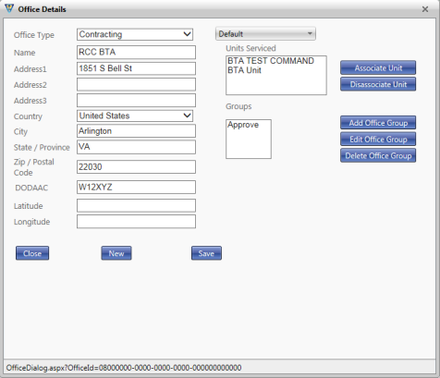

* + This better prepares the 3in1 Tool system for upcoming usage scenarios where the geo-locations of AOR/Offices/Order Placements need to be tracked; it sets the structure for the next-generation of visual-based information systems by allowing coordinates of Offices to be tracked, and potentially displayed on maps or other visual tools (Common Operating Pictures, etc)
* 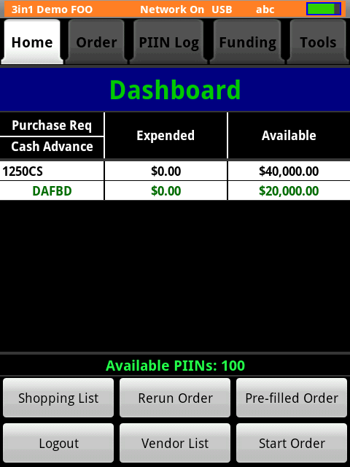**Standardized 3in1 Device Demo Mode Data**
  + All 3in1 Devices will now generate the exact same demo mode data
  + This will streamline 3in1 Device training, reducing the potential for confusion among newly trained users that previously saw a different data set displayed on their 3in1 Device than what was displayed in their 3in1 training materials
* **Fixed Network Thread and Mass Storage Class (MSC) issues on 3in1 Device**
  + Removed unsafe and unstable operations from the 3in1 Device network thread; also replaced fragile MSC functionality by utilizing 3in1 Device internal storage
  + This stabilizes the 3in1 Device software, fixing multiple device bugs that were periodically manifesting themselves as Blue Screens of Death (BSODs) upon uploading/provisioning/deprovisioning
* **Increased Decimal Places within the Price field on the 3in1 Device**
  + By increasing the number of digits that the price field supports on the 3in1 Device, the possibility of users requiring the usage of another system to make calculations in order to fully utilize the 3in1 Device is eliminated
* **Merged functionality of 3in1 Device Support Apps into Factory App**
  + System complexity, and potential for errors, is reduced by merging the functionality of four external support apps into the main factory app
  + 3in1 Devices are less likely to enter into a “hangup state” in the event of failure during the device update process
* **Simplified the Over-the-Air Update Approach to the 3in1 Device**
  + For device software upgrades, the local data storage option has been removed
  + Device data must now be saved to the 3in1 Production server/database before starting the update process
  + This allows for easier packaging of device updates, as well as easier/more reliable testing of the device update process
* **Reduced “Get Component” Calls from 3in1 Device**
  + The frequency of the 3in1 Device’s automatic data request to the 3in1 Production server/database has been reduced to once every 12 hours
    - The 3in1 Device may still be directed manually by the device user to request data from the 3in1 Production server/database as often as needed
  + This reduces excessive server traffic, allowing the 3in1 Production Server/Database to operate more efficiently
* **Included 3in1 Device Reset to Factory Code Generator within 3in1 Website**
  + Previously, the 3in1 Device Reset to Factory Code Generator was a standalone software that required a separate installation
  + This often-used 3in1 SME feature may now be accesses within the 3in1 Website, consolidating a piece of 3in1 functionality within the 3in1 Tool system itself
  + This feature may be accessed only by 3in1 System Admins
    - Navigate to Device Management/Manage Device
    - Click “Reset to Factory” to initialize functionality

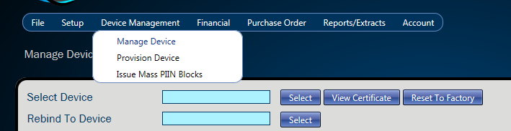

* **Additional Items of Note:**
  + The 3in1 Website (Production environment) may be accessed at the following link: <https://www.jccs.gov/3in1/Login.aspx>
  + Users who wish to continue using the 3in1 Workstation may do so by downloading the 3in1Workstation3604.zip file at the following link: <https://www.jccs.gov/3in1/Default.aspx>
    - V3.6 of the 3in1 Tool system maintains support of the 3in1 Workstation, as well as the newly-enhanced 3in1 Website
  + The 3in1 Website (Training environment) may be accessed at the following link: <https://jccs-mcoop.csd.disa.mil/3in1Training/Login.aspx>

Please contact the 3in1 Team at [3in1support@dla.mil](mailto:3in1support@dla.mil) with any further questions/concerns